1. **Entity-Relationship (ER) Model**

To develop the dimensional model for Fufu Republic, we first need to understand the key entities, relationships, and constraints based on the business context.

**Entities:**

1. **Branch**: Represents each location of Fufu Republic (e.g., Lekki, Agege).

Attributes: Branch ID, Branch Name, Location, Contact Info.

1. **Customer**: Represents individuals who purchase food either online or in-store.

Attributes: Customer ID, Name, Email, Phone Number, Address, Payment Method Preferences.

1. **Menu Item**: Represents food items available at Fufu Republic (some items vary by branch).

Attributes: Item ID, Name, Price, Branch Availability, Category (e.g., Main Course, Dessert).

1. **Order**: Represents a customer’s order (dine-in, take-out, or online).

Attributes: Order ID, Customer ID, Branch ID, Order Type (Dine-in/Take-out/Online), Total Amount, Order Date, Payment Method.

1. **Payment**: Tracks payment transactions made by customers for orders.

Attributes: Payment ID, Order ID, Payment Method, Amount Paid, Payment Status, Payment Gateway (e.g Paystack, etc.).

1. **Inventory**: Represents the stock levels of menu items in each branch.

Attributes: Inventory ID, Branch ID, Item ID, Quantity in Stock, Last Restocked Date.

**Relationships:**

* A **branch** has many **orders**.
* A **customer** can place multiple **orders**.
* An **order** can have multiple **menu items**.
* Each **order** has a single **payment**.
* A **menu item** can be stocked in many **branches**.
* **Inventory** is tied to a specific **branch** and **menu item**.

**Constraints:**

* A **payment** must be linked to an **order** (mandatory relationship).
* **Menu items** must be available at specific branches for customers to order.
* **Order** dates and **payment** dates must be consistent (e.g., a payment cannot be made before the order).

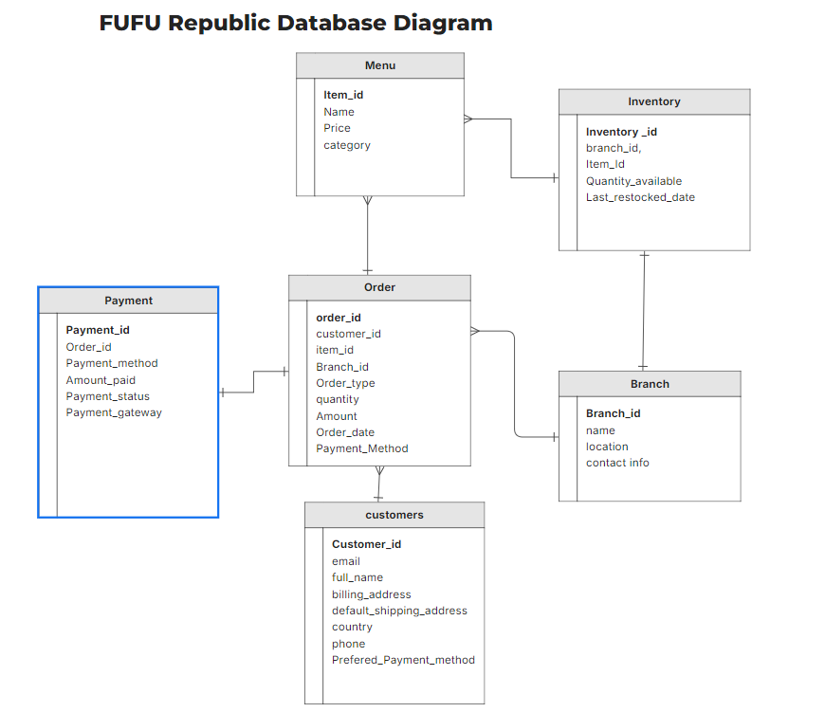

**2. Dimensional Model:**

**Selected Business Process:**

*Inventory Management*

This process is critical for understanding stock levels across branches and ensuring optimal inventory handling based on sales trends.

**Business Questions:**

* What are the stock levels of menu items in each branch?
* Which menu items are sold the most and require frequent restocking?
* How does demand vary by menu item, branch, and time of day/week?
* How do sales trends impact inventory needs for each branch?

**Grain:**

The grain is at the **daily stock level per menu item per branch**. This means that the fact table will record one row per day, for each menu item and each branch, representing the stock level and any sales for that day.

**Dimensions:**

1. **Date Dimension**: Date ID, Day, Month, Year, Weekday, Holiday Indicator.
2. **Branch Dimension**: Branch ID, Branch Name, Location, Region, Branch Manager.
3. **Menu Item Dimension**: Item ID, Item Name, Category, Price, Description.
4. **Customer Dimension** (optional, for customer-specific trends): Customer ID, Name, Age, Gender, Loyalty Program Status, Contact Info.
5. **Order Dimension** (optional, if linked to stock depletion): Order ID, Order Type (Dine-in/Take-out/Online), Total Amount, Payment Method.

**Fact Table: Inventory Fact**

This table will record daily inventory levels and sales at each branch.

**Fact Table Attributes**: Date ID, Branch ID, Menu Item ID, Opening Stock Quantity, Quantity Sold, Closing Stock Quantity, Restocked Quantity, Sales Revenue (Price × Quantity Sold)

**Example Fact Table Schema:**

|  |  |  |  |  |  |  |  |
| --- | --- | --- | --- | --- | --- | --- | --- |
| **Date_ID** | **Branch_ID** | **Item_ID** | **Opening_Stock** | **Quantity_Sold** | **Closing_Stock** | **Restocked_Quantity** | **Sales_Revenue** |
| 20240901 | 1001 | 2001 | 100 | 30 | 70 | 50 | 15,000 |
| 20240901 | 1002 | 2001 | 80 | 25 | 55 | 40 | 12,500 |

**Business Analytics:**

Using this model, the business can answer the following:

* Which branches are consistently running low on key menu items?
* What are the sales patterns by menu item and branch?
* How frequently should branches be restocked for specific items?
* How do payment methods correlate with sales trends?

This dimensional model allows Fufu Republic to optimize inventory management and improve overall operational efficiency.